Create Socrative surveys
Go to beta.socrative.com and click ‘Get a free account’.
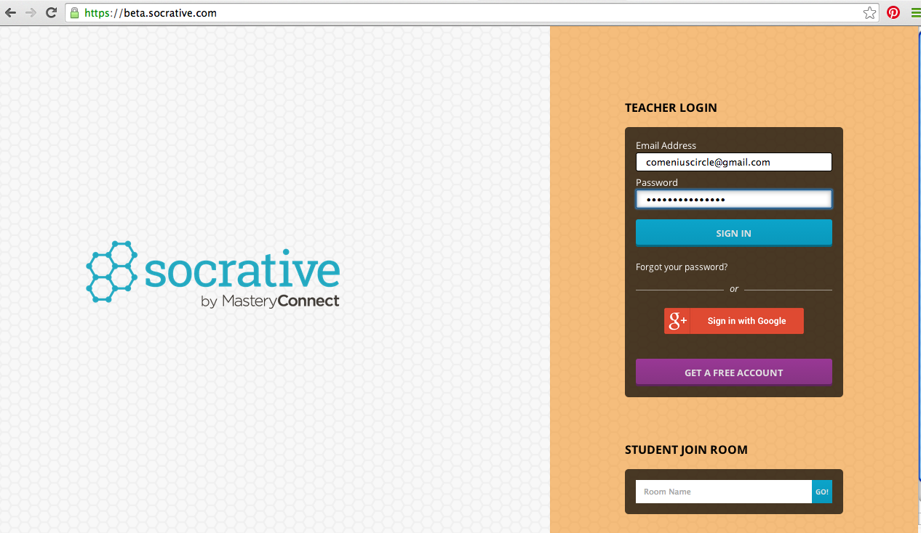

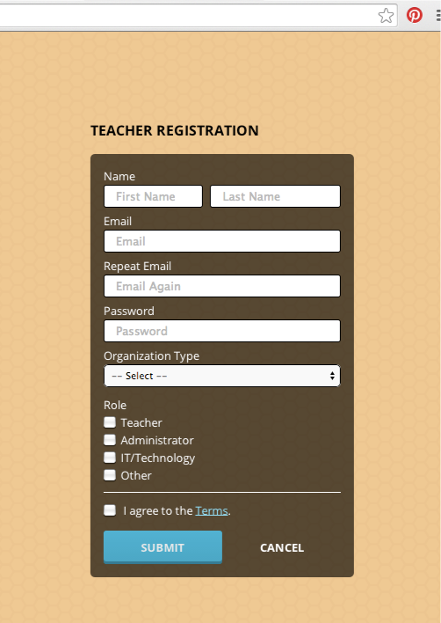
Complete the registration form with your personal details.
Choose K-12 from the list ‘Organization Type’
Socrative is an American service and K-12 is the term for all pupils from Kindergarden to 6th grade secondary school
Click ‘Submit’ when you’re done.

Now you can log in with your personal details.
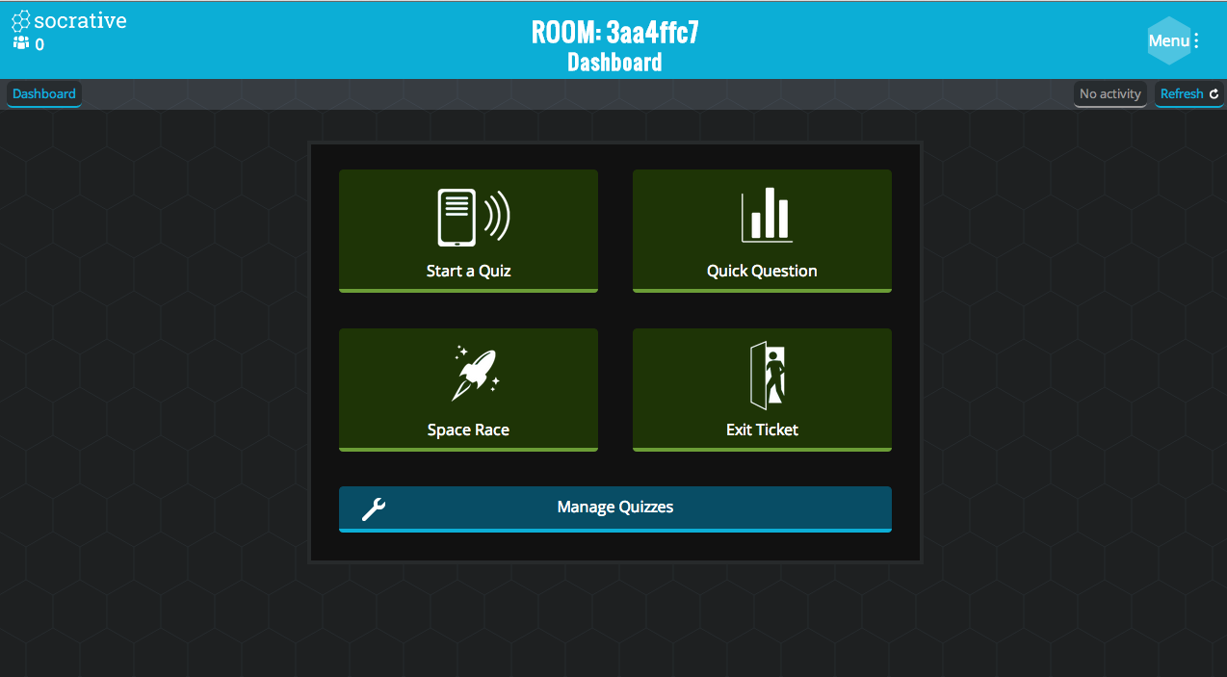
We’ll explain to you how you ‘Start a Quiz’. However we’ll explain the other options briefly: Quick Question, Space Race, Exit Ticket en Manage Quizzes.
Quick Question
This is just 1 question you want to ask your pupils/students. It’s suitable for quick, realtime evaluation. You can’t save this or use an existing quiz in this option.
Space Race
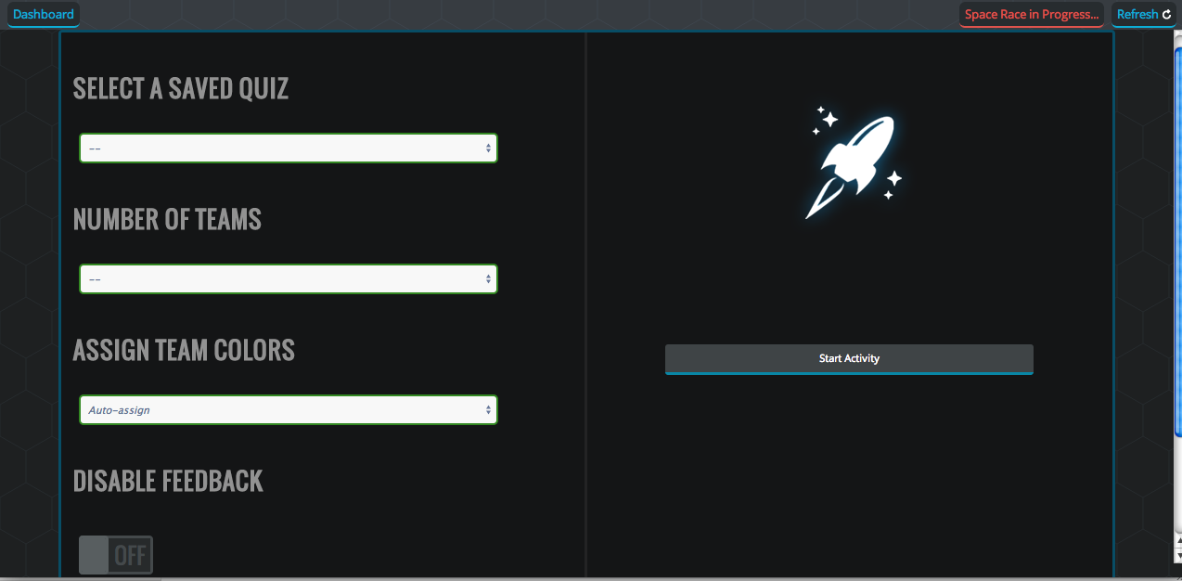
Space Race is a tool to let teams take the quiz as quickly as possible. Perhaps not suited for questions that require some thinking but it can be fun if speed is more important than thinking.
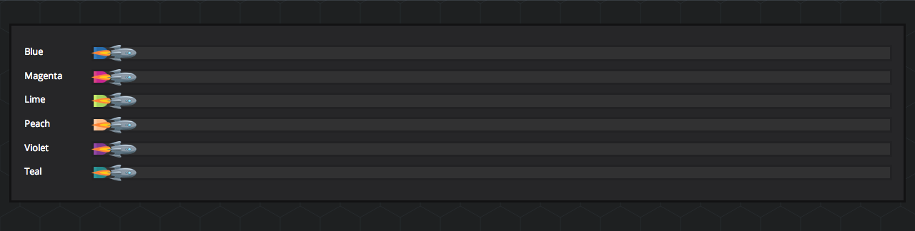
You can select a saved quiz, the number of teams, and the team colors. The rocket that reaches the end of the line first is the winner.

Exit Ticket
Exit Ticket has some pre-build questions in it. As socrative is American these questions are all English question.

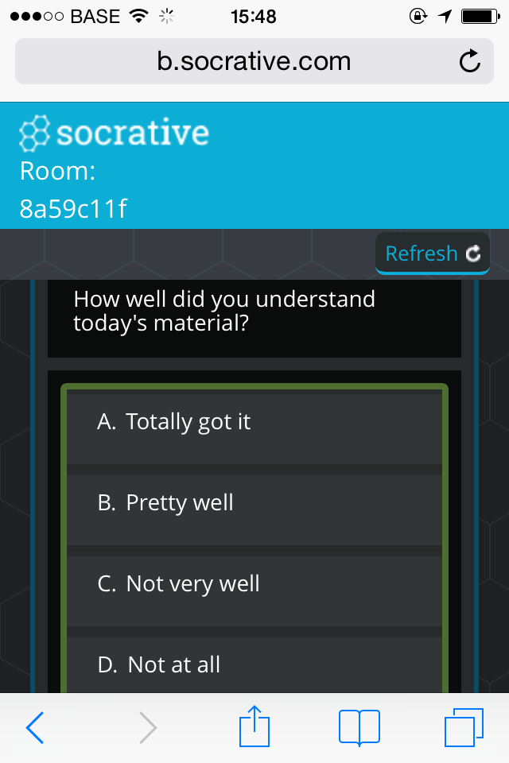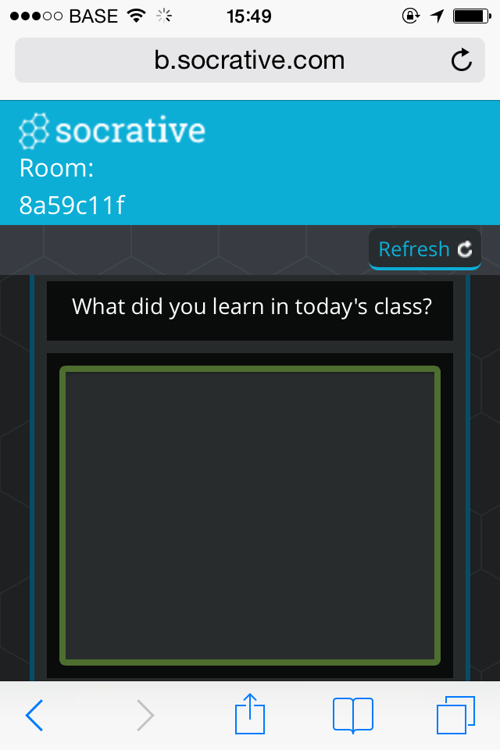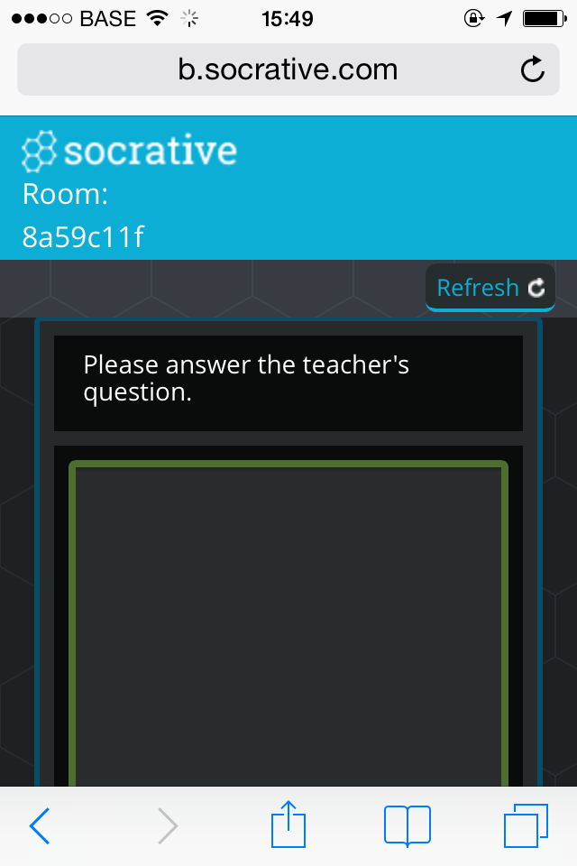

Manage Quizzes
This option lets you create and manage your own quiz.
We have 4 options: ‘Create Quiz’, ‘Import Quiz’ (quiz importeren), ‘My Quizzes’ (show the quizzes you made and saved) en ‘Reports’ (detailed reports of all your quizzes).
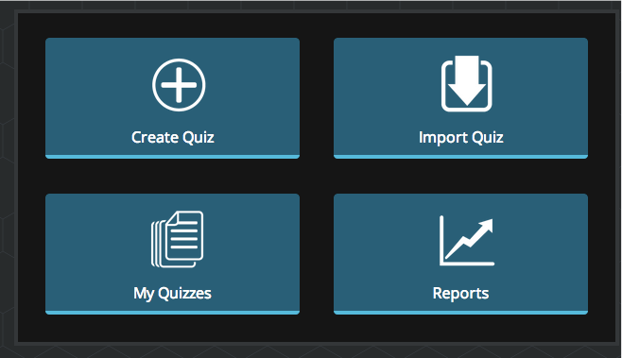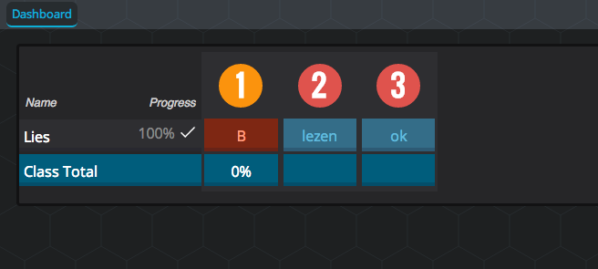

Create Quiz
Name your quiz first.
Now you can add 3 types of questions:
- Multiple Choice
- True/False
- Short answer
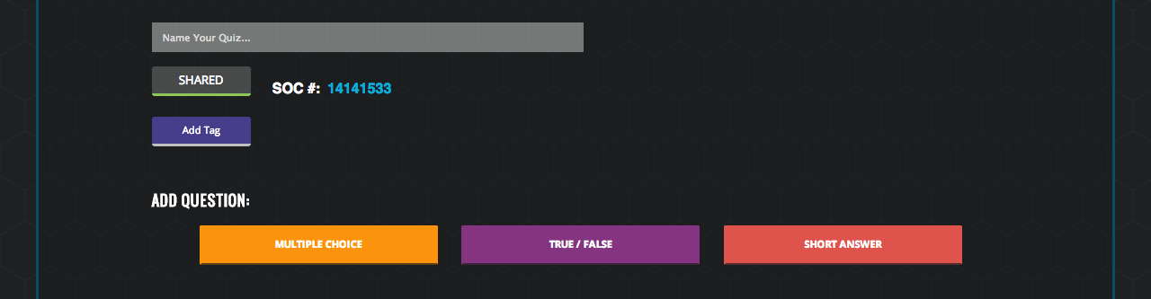

Every question has some options. You can add an explanation or an image to the question.
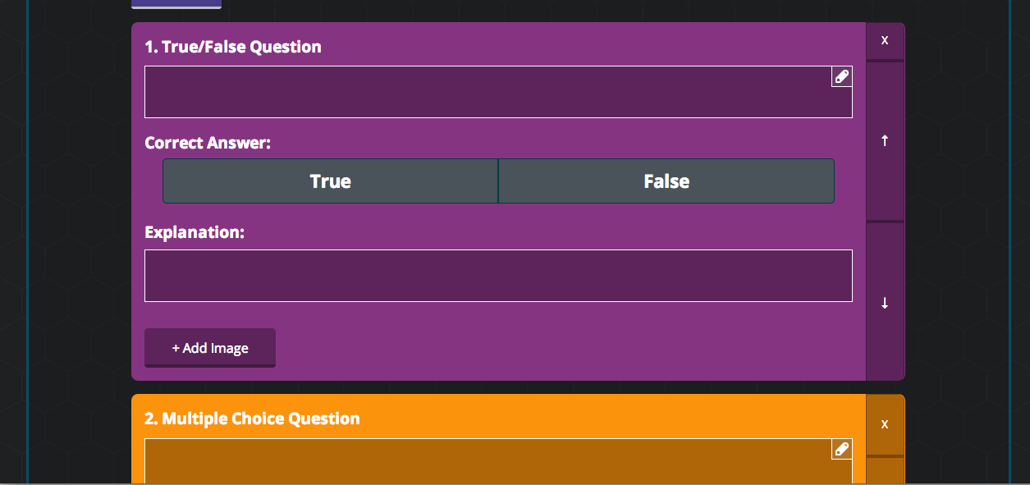

You can drag your questions using the up or down arrows you see on the right side.
Don’t forget to ‘Save & Exit’ when your quiz is ready.

Import Quiz
You can import quizzes from other teachers too. You have to ask the SOC-number to do this.
A quiz made in Microsoft Exel can also be imported.
My Quizzes
Here you can manage your quizzes.
- Duplicate a quiz.
- Delete a quiz (this can not be undone).
- Download a quiz.
- Edit a quiz. (Add or remove questions. Don’t forget to ‘Save & Exit’ when you’re done.)
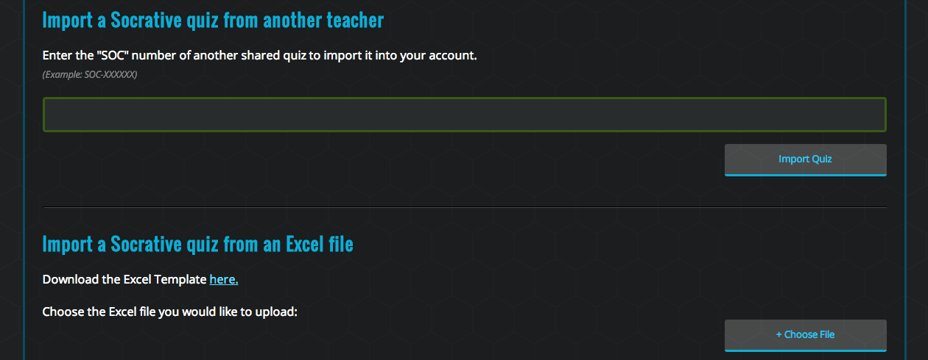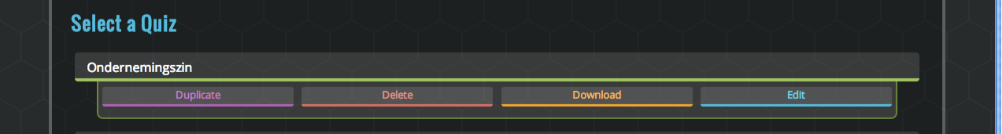
Reports
Here you can view the results from al quizzes made from your account

